**Module 1**

1. **Define following terms with respect to optical laws –**
2. Reflection: is the phenomenon of light ray which bounces back when it strikes a smooth and shiny surface.

The angle of incidence is equal to angle of reflection is called as law of reflection.

As shown in Fig. the angle made by incident ray with respect to normal is called as angle of incidence. ${(ϕ}_{1})$

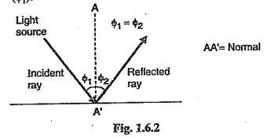

Similarly the angle made with vertical line, at which the light is reflected from the surface is called as angle of reflection. ${(ϕ}_{2})$

Now $ϕ_{1}= ϕ_{2}$ is called as the law of reflection.

1. Refraction

When the light ray travels from one medium (air) to another medium (glass) then bending of light ray takes place as shown in Fig. It is called as refraction.

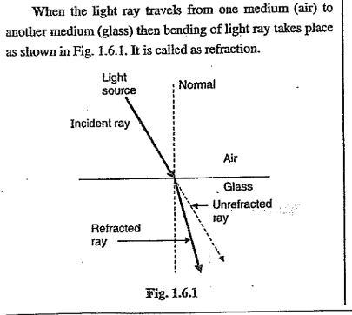

1. Refractive index:

It is defined as the ratio of speed of light in air (c) to the speed of light in another medium like glass (v).

$n= \frac{c}{v}$

1. Snell‘s law

**When the light ray meets the interface of two media having different index of refraction then part of light ray is reflected back into the first medium and other part is refracted into the second medium.** It is shown in Fig. And it is called as Snell’s law.

$$n_{1}\sin{ϕ_{1}}= n_{2}\sin{ϕ_{2}}$$

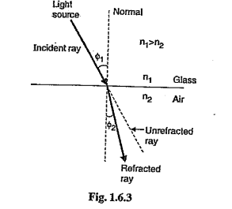

1. **Critical angle:** It is the minimum possible angle of incidence at which if a light ray is incident at the intersection of two different mediums, then it gets refracted with an angle of refraction exactly equal to 90°. This phenomenon is usually called the critical angle.

Consider the light ray making an angle of incident ' $ϕ_{1}$' as shown in Fig.

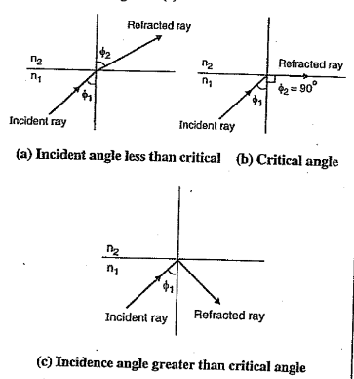

The light ray gets reflected by making an angle of refraction (). Here n1, and n2 are the refractive indices of two medium.

Now according to Snell's law,

$n_{1}\sin{ϕ_{1}}= n_{2}\sin{ϕ_{2 }}$...(1.6.1)

Now as the value of ' $ϕ_{1}$' goes on increasing the value of ' $ϕ_{2}$' also gets increased.

At one particular stage the value of ' $ϕ_{1}$' is such that it makes angle ' $ϕ_{2}$' equal to 90°. This is called as the critical angle of incidence ( $ϕ_{c}$). This is as shown in fig(b)

Thus using Snell's law,

$n_{1}\sin{ϕ_{1}}= n_{2}\sin{{90}^{0}}$...(1.6.2)

where,

$ϕ_{c}$ = Critical angle of incidence

$n_{1}\sin{ϕ_{c}}= n_{2}$

$$\sin{ϕ_{c}}= \frac{n_{2}}{n_{1}}$$

$ϕ_{c}= \sin^{-1}\left(\frac{n_{2}}{n_{1}}\right)$...(1.6.3)

1. **Total internal reflection (TIR)**

* If angle of incidence is increased than critical angle, then the light ray gets reflected rather than causing refraction. Now inside the fiber optic cable the incident light ray should cause the total internal reflections.
* If the refraction of light ray occurs, then the light rays will not enter into the fiber optic cable. In this case the light rays will get escaped.
* Thus, the total internal reflection occurs at the interface between two dielectrics having different refractive indices; when the light is incident on dielectric of lower index from the dielectric of higher index and angle of incidence is greater than critical angle.
* Consider a light ray having angle of incidence $ϕ$ at the interface of core and cladding as shown in Fig.
* This ray is reflected at the same angle $ϕ$ and it causes the total internal reflection.
* In this case, the light ray propagates through optical fiber by keeping the shallow angle (less than 90° - $ϕ_{c}$).
* This is called as meridional ray and it passes through the axis of fiber core.
* The total internal reflection occurs only in materials in which the speed of light is slower than in air.

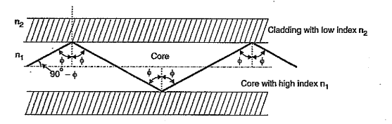

1. **Fresnel Reflection**

* The reflection of a portion of light resulting when light is incident upon the surface between materials that have different refractive indices is called as Fresnel Reflection. This Fresnel reflection depends upon the index difference and the angle of incidence.
* For example, at input side there is interface of air and optical cable and at the output side there is interface optical cable and air. Due to change in refractive index, reflection of light takes place. Such reflection occurs at the air-glass interfaces at entrance and exit ends of an optical waveguide.
* Resultant transmission losses (on the order of 4 percent per interface) can be virtually eliminated by the use of antireflection coatings or index-matching materials. For the simplest case with normal incidence on the interface, the Fresnel reflectivity can be calculated with the following equation:

$$R= {\left(\frac{n_{1}- n_{2}}{n_{1}+ n_{2}}\right)}^{2}$$

1. **External reflection**

* It is the phenomenon in optical cable when the light ray, at certain angle, gets totally reflected from interface of core and cladding.
* External reflection is the situation where the light starts in air and vacuum (refractive index 1), and bounces off a material with index of refraction less than 1.
* Some materials have an index of refraction that is less than one at the frequency of the incident field. This is rare in the visible light spectrum, but common for x-rays.

1. **Acceptance angle**

* It is defined as the maximum (not minimum) external angle of incidence at which the external light rays must strike the air/glass (fiber core) intersection and enters the fiber core and propagate within it.
* For the propagation of signal through the fiber; there must be total internal reflection of light rays. The total internal reflection of light ray takes place if angle of incidence is greater than the critical angle.
* The maximum angle at which light enters the fiber and causes internal reflection is called as acceptance angle of an optical fiber.

$$ϕ_{a}= \sin^{-1}{(NA)}$$

1. **Differentiate between step index and graded index fiber.**

| **Sr No.** | **step index fiber** | **graded index fiber** |
| --- | --- | --- |
| 1. | There is a step change in the refractive index at the core cladding interface. | There is continuous change in refractive index. |
| 2. | More modal dispersion. | Less modal dispersion. |
| 3. | Less bandwidth capabilities. | More bandwidth capabilities. |
| 4. | Transmission bit rate is low. | Transmission bit rate is high. |
| 5. | The propagation of light rays is in zigzag manner. | The propagation paths are predictable and orderly. |
| 6. | Coupling of light rays is simple. | Coupling of light rays is difficult. |
| 7. | Typical core diameter is 125 to 400 µm. | Typical core diameter is 50 to 100 µm. |
| 8. | Easy to manufacture. | Due to continuously changing refractive index; manufacturing is difficult. |

| **Sr No.** | **Single-mode Fiber** | **Multimode Fiber** |
| --- | --- | --- |
| 1. | Propagation of only one mode takes place. | Many modes propagate at the same time. |
| 2. | Due to small core diameter, launching of optical power is difficult. | Due to large core diameter, launching of optical power is easy. |
| 3. | Due to single mode, there is no intermodal dispersion. | Many modes travel with different speeds; so intermodal dispersion occurs. |
| 4. | Duration of input and output pulse is same. | Output pulse is spreadout compared to input pulse. |
| 5. | LED cannot be used as light source. | LED can be used as light source. |
| 6. | At 850 nm; attenuation is about 2 to 5 dB/km. | At 850 nm; attenuation is about 2.6 to 50 dB/km. |
| 7. | Higher bandwidth (greater than 400 MHz / km) | Less bandwidth (6 to 50 MHz / km) |
| 8. | V number is less than 1.15 | V’ number is greater than 1.15 |
| 9. | Applicable to long distance communication | Applicable for short distance communication |
| 10. | Applications: Long distance telephony, multichannel television broadcasting | Applications: LAN networks and video surveillance |

1. **Define numerical aperture and state its significance also? Derive the expression of Numerical Aperture of Step- index fiber. What will happen to Numerical Aperture if cladding is removed?**

Ans: Consider the light ray enters inside the fiber optic cable by making an angle $ϕ_{a}$, with respect to the axis of the fiber optic cable. This light rays strikes to the boundary of core cladding interface and make an angle equals to critical angle. This situation is as shown in Fig.

Here

n0 = Refractive index of air = 1

n1 = Refractive index of the core

n2 = Refractive index of cladding

and $ϕ_{a}$ = Angle of incidence.

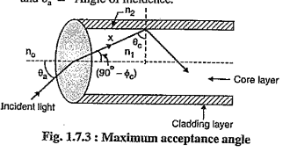

Now according to Snell's law,

$n_{0}\sin{θ_{a}}= n_{1}\sin{({90}^{0}-ϕ_{c})}$----- (1.7.1)

Where $ϕ_{c}$ = Critical angle.

But $\sin{({90}^{0}-ϕ_{c})}= \cos{ϕ_{c}}$

∴ $n_{0}\sin{θ_{a}}= n_{1}\cos{ϕ_{c}}$----- (1.7.2)

Since the value of no that means refractive index of air is always 1, so the value of $n_{0}\sin{θ_{a}}$, is not dependent on $n_{0}$. This is called as **numerical aperture of fiber optic cable.**

∴ From Equation (1.7.2) we have,

${NA= n}_{1}\cos{ϕ_{c}}$----- (1.7.3)

But $\cos{ϕ_{c}}= {\left[1- \sin^{2}{ϕ_{c}}\right]}^{1/2}$----- (1.7.4)

∴ $NA = n_{1}{\left[1- \sin^{2}{ϕ_{c}}\right]}^{1/2}$

We have the equation of $ϕ_{c}$, in terms of n1 and n2 as,

Equation (1.7.4) becomes,

${NA= n}_{1}{\left[1- \frac{n_{2}^{2}}{n_{1}^{2}}\right]}^{1/2}$

∴ $NA ={\left[n_{1}^{2}- n_{2}^{2}\right]}^{1/2}$---- (1.7.5)

But from Equations (1.7.1) and (1.7.2),

$$NA= n_{0}\sin{θ_{a}}$$

Since n0 = 1,

∴ ---- (1.7.6)

Now if n1 = n2 Then n1 + n2 = 2n1

∴ ---- (1.7.7)

The relative refractive index difference between core and cladding is given by,

$∆ = \frac{{ n}_{1}- { n}_{2}}{{ n}_{1}}$ for A << 1

$∆ { n}_{1} ={ n}_{1}- { n}_{2}$---- (1.7.8)

Putting Equation (1.7.8) in Equation (1.7.7) we get,

$NA= \sqrt{2 n_{1} ×∆ n_{1} }= n_{1} \sqrt{2∆}$---- (1.7.9)

If cladding is removed the step index fiber behaves like a cylindrical circular optical fiber with n2=1 of air.

Thus, NA increases if the cladding is removed.

The significance of numerical aperture lies in its relationship with the resolving power and light-gathering ability of the optical system. A higher numerical aperture allows the system to gather more light and resolve finer details of an object being observed. In microscopy, for example, a higher numerical aperture leads to better resolution and increased contrast in the images produced, enabling the observation of smaller structures with greater clarity. Therefore, numerical aperture is a crucial parameter in determining the performance of optical instruments, particularly in fields such as microscopy and photography.

1. **State and explain the advantages and disadvantages of fiber optic communication systems?**

**Advantages of Optical Fiber communication:**

1. **Enormous potential Bandwidth:** The information carrying capacity of a fiber is directly proportional to the frequency of signal. The frequency of light signal is 1014 Hz as compared to 10% Hz of electrical communication. Thus a lot of information can be carried and hence enormous bandwidth.
2. **Small size and weight**: Optical fibers have very small diameter. Hence, even when they are covered with protective coating, they are far smaller and lighter. This is tremendous boon towards the alleviation of duct congestion in cities and allowing expansion of signal transmission within mobiles such as aircrafts, ships etc.
3. **Electrical Isolation:** Optical fibers which are fabricated from glass, or sometimes a plastic polymer, are electrical insulators and therefore, unlike their metallic counterparts, they do not exhibit earth loop and interface problems. Furthermore, this property makes optical fiber transmission ideally suited for communication in electrically hazardous environments.
4. **Immunity to interference and crosstalk:** Optical fibers form a dielectric waveguide and therefore are free from electromagnetic interference (EMI), Radio frequency Interference (RFI). It is not susceptible to lightening striker if used over head rather than underground. Moreover, it is easy to ensure that there is no optical interference between fiber.
5. **Signal security.** The light from optical fibers does not radiate significantly and therefore they provide a high degree of signal security.
6. **Low transmission loss:** The loss in the optical fiber is very less around 0.15 dB/km. It facilitates the implementation of communication links with extremely wide optical repeater or amplifier spacings, thus reducing both system cost and complexity.
7. **Ruggedness and flexibility:** Although protective coatings are essential, optical fibers may be manufactured with very high tensile strengths. Perhaps surprisingly for a glassy substance, the fibers may also be bent to quite small radii or twisted without damage.
8. **System reliability and ease of maintenance**: These features primarily stem from the low- loss property of optical fiber cables which reduces the requirement for intermediate repeaters or line amplifiers to boost the transmitted signal strength. Hence with fewer optical repeaters or amplifiers, system reliability is generally enhanced in comparison with conventional electrical conductor systems. Furthermore, the reliability of the optical components is no longer a problem with predicted lifetimes of 20 to 30 years being quite common. Both these factors also tend to reduce maintenance time and costs.
9. **Potential low cost:** The glass which generally provides the optical fiber transmission medium is made from sand - not a scarce resource. So, in comparison with copper conductors, optical fibers offer the potential for low-cost line communication.

**Disadvantage of Optical Fiber Communication:**

1. **Low power:** Light emitting sources are limited to low power. Although high power emitters are available to improve power supply, it would add extra cost.
2. **Difficult to Splice:** The optical fibers are difficult to splice, and there are loss of the light in the fiber due to scattering. They have limited physical arc of cables. If you bend them too much, they will break.
3. **Expensive to Install:** The optical fibers are more expensive to install, and they have to be installed by the specialists. They are not as robust as the wires. Special test equipment is often required to the optical fiber.
4. **Highly Susceptible:** The fiber optic cable is a small and compact cable, and it is highly susceptible to becoming cut or damaged during installation or construction activities. The fiber optic cables can provide tremendous data transmission capabilities. So, when the fiber optic cabling is chosen as the transmission medium, it is necessary to address restoration, backup and survivability.
5. 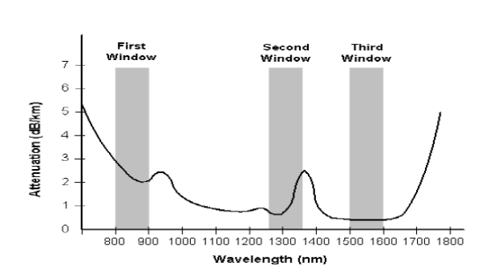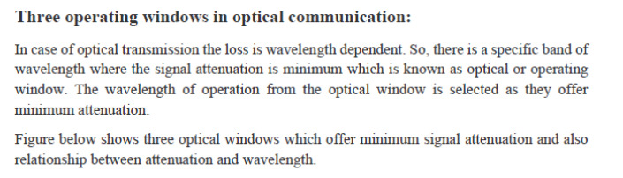**With a neat sketch explain the optical bands and three operating windows in optical communication. Which band is known as extended “C” band?**

| **Window** | **Range** | **Operating Wavelength** |
| --- | --- | --- |
| First Window | 800 nm – 900 nm | 850 nm |
| Second Window | 1,260 nm – 1,360 nm | 1,310 nm |
| Third Window | 1,500 nm – 1,600 nm | 1,550 nm |

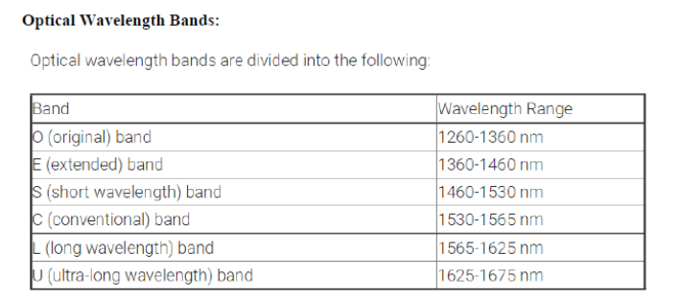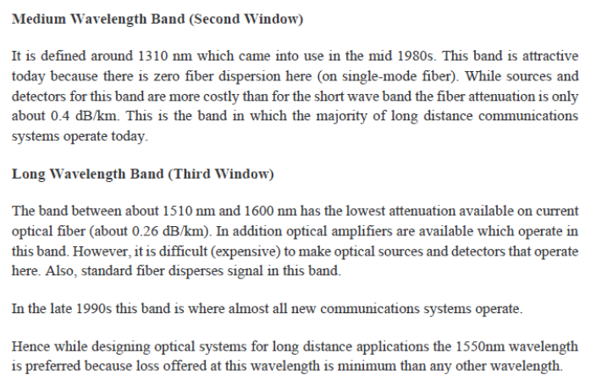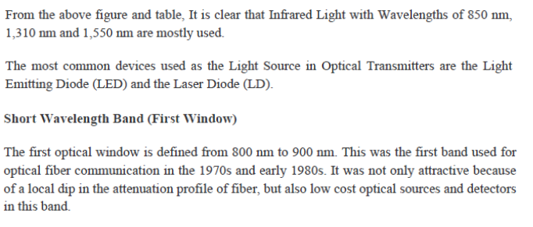

**Extended "C" Band:**

The band known as the extended "C" band corresponds to the Second Operating Window (E-Band), as mentioned earlier. It extends the traditional C-Band to longer wavelengths, providing additional capacity and improved performance in optical communication systems, particularly for long-haul applications.

1. **Draw the block diagram of optical communication**

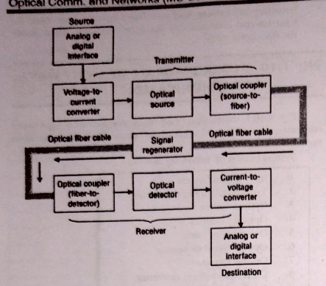

* + - 1. Information Source: The source information may be the form of non-electrical, physical form such as voice or image/video. An input transducer is a device that converts physical information into an electrical signal. The input signal can either be an analog or digital (computer data).
      2. Voltage-to-current converter: It serves as an electrical interface between the information source circuit and the optical (light) source. The amount of light emitted by the light source is generally proportional to the amount of its drive current. Thus, the voltage-to-current converter is necessary to convert an input signal voltage to a current that is used to drive the light source.
      3. Optical source: In an optical transmitter, the optical carrier signal generated by optical source is modulated by an analog or a digital signal. The optical source is either a light-emitting diode (LED) or an injection laser diode (ILD), which generates an electromagnetic wave in the infrared region of the optical spectrum. In essence, the light intensity is modulated by the input signal. The optical sources are generally compact, lightweight, consume moderate amount of power, and are relatively easy to modulate.
      4. Optical couplers: The function of source-to-fiber coupler is to collect the light signals from the optical source and send it efficiently to the optical fiber cable. Similarly, the fiber-to-detector coupler is used at the other end of the fiber cable to direct the received light signals onto the photodetector.
      5. Optical fiber cable: It is the guided transmission medium, which is either an ultrapure glass or a plastic cable. The optical fiber consists of a glass or plastic fiber core surrounded by a cladding and then encapsulated in a protective jacket. Techniques have been developed for the production of fibers with very low transmission losses (a few tenths of a dB/km at 1300 nm and 1550 nm optical wavelengths).
      6. Optical signal regenerators: As the optical signals (in the form of intensity-modulated light pulses) propagate along the lengths of the optical fiber cable from the source to destination, they get attenuated (due to absorption, scattering, etc.) as well as broadened (due to dispersion). As a result, the signals may become weak and indistinguishable after a certain distance. Optical regenerators (or optical amplifiers, such as erbium-doped fiber amplifiers) are used at appropriate distances from the transmitter along the length of the fiber cables which help to restore the strength and shape of transmitted signal.
      7. Optical detector: The optical detector is generally a p-i-n (p-type-intrinsic-n-type) diode, an avalanche photodiode (APD), or a phototransistor which converts an input optical signal into an equivalent electrical signal, usually in the form of electric current. The resultant output current is normally proportional to the incident optical signal level and hence to the input information signal. The optical detectors are generally compact, consume low power, and have flat spectral response, and long operating life.
      8. Current-to-voltage converter: It transforms variations in photodetector current to corresponding variations in voltage. It produces an output voltage which is proportional to the original source information.
      9. Destination output: Finally, the received information is presented in a form similar to that of input information source and suitable for destination device such as loud speaker, computer, or other machines.

1. **Explain different types of fibers? Explain different types of fibers with their refractive index profile and mention its dimensions? Draw refractive index profile of a graded index fiber, Step index fiber and show with neat diagram transmission of light through this fiber.**

Different classification are :

1. **Based on the refractive index profiles of the fiber core**, there can be two types of optical fibers, namely,

* Step-index optical fiber
* Graded-index optical fiber

1. **Based on the number of modes** (rays or light wave patterns) propagated within the optical fiber, there can be two types of optical fibers. These are

* Single-mode optical fiber
* Multi-mode optical fiber

1. **Based on the improvement in propagation properties,** there can be three different types of optical fibers, such as

* Polarization-maintaining optical fiber
* Dispersion-shifted optical fiber
* Dispersion-flattened optical fiber

**Based on the refractive index profiles:**

1. **Step-index optical fiber**
   1. The optical fiber with a core of constant refractive index n1 and a cladding of a slightly lower refractive index n2 is known as step index fiber.
   2. This is because the refractive index profile for this type of fiber makes a step change at the core–cladding interface, as indicated in Figure 1.26, which illustrates the two major types of step index fiber.

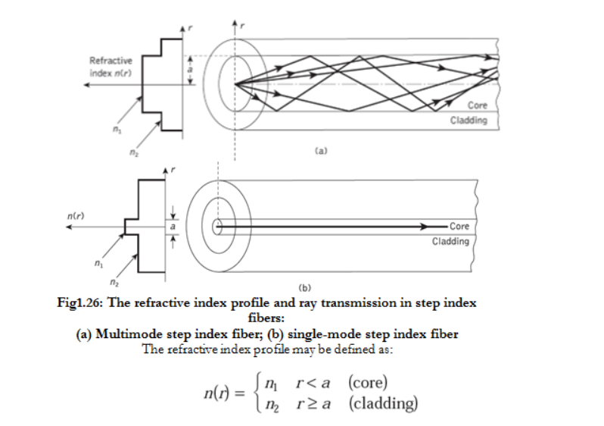

**Standard single-mode fiber:**

Cladding diameter: generally 125 μm

Coating diameter: 200 to 300 μm

Buffer jacket diameter: 500 to 1000 μm

Numerical aperture: 0.08 to 0.15, usually around 0.10.

**For Multimode Step Index Fiber:**

Core diameter: 100 to 300 μm

Cladding diameter: 140 to 400 μm

Buffer jacket diameter: 400 to 1000 μm

Numerical aperture: 0.16 to 0.5

1. **Graded-index optical fiber**

* The refractive index of core layer is not constant. It varies smoothly and continuously over the diameter of core layer.
* The refractive index changes proportionally as the distance varies from core axis to the cladding layer. Since the refractive index of core is varying; it is called as inhomogeneous core fiber.
* On the axis of core; the refractive index is maximum. It is denoted by n1.

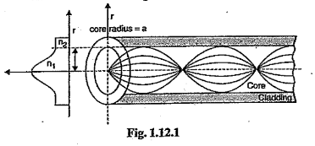

* The refractive index goes on decreasing with the radial distance as shown in Fig. 1.12.1.
* The reduction in refractive index takes place from core axis to the cladding layer.
* But in the cladding layer; the refractive index is constant.
* It is denoted by n2.
* Due to continuously changing refractive index; the propagation of light rays is not along straight line paths.
* Consider the propagation through multimode graded index fiber as shown in Fig. 1.12.2.

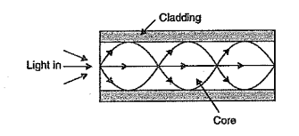

* For the curved path; the velocity of propagation goes on changing with respect to change in refractive index.
* At the centre of core; the refractive index is maximum. So, axial ray passing along centre of core is having slowest speed.
* Due to the difference in speeds of different paths; even though the distance travelled by each path is different, all paths reach the output at the same time.
* Let 'α' denotes the profile parameter, which gives the characteristic refractive index profile of core layer.
* The value of α decides the shape of the refractive index profile curve.
* The relative refractive index difference is denoted by $∆$. Then index variation in graded index fiber is given by,

$n\left(r\right)= n_{1}\sqrt{1-2∆{\left(\frac{r}{a}\right)}^{α}}$ r ≤ a (core layer)

$n_{2}= n_{1}\sqrt{1-2∆}$ r > a (cladding layer)

* As the value of α changes, the shape of refractive index profile also changes as shown in Fig. 1.12.3.

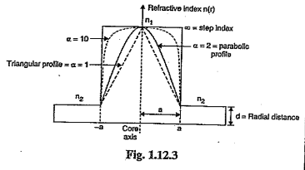

* For α = 1; the refractive index profile is triangular. For α=2; the profile is parabolic and when α becomes ∞, we will get step index profile instead of graded index profile.

**For Multimode Graded Index Fiber:**

* Core diameter: 50 to 100 μm
* Cladding diameter: 125 to 150 μm
* Coating diameter: 200 to 300 μm
* Buffer jacket diameter: 400 to 1000 μm
* Numerical aperture: 0.2 to 0.3

**Based on the number of modes**

1. **Single-mode optical fiber:**

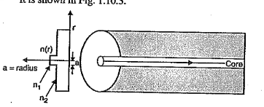

* 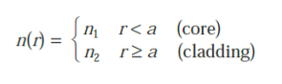The refractive index profile of step index fiber is defined as,
* As the name indicates these optical fibers allows a single mode of data transmission.
* And there is an abrupt change in the refractive index.
* Here the core layer is made from dopped silica material and a cladding is made from borosilicate material.
* This type of optic fiber provides a high bandwidth about 500 MHz.
* The cladding is coated with silica.
* The pair of jacket layers are used to provide the protection.

**Advantages**

* Since only one mode is propagated; there is no loss of energy through leakage due to the higher modes.
* At the output; there is less broadening (dispersion) of pulse. That means less intermodal dispersion.
* Less attenuation of signal in the fiber.
* The duration of output pulse is same as that of input pulse.
* The data can be transmitted with higher bandwidth (above 400 MHz/km).

**Disadvantages**

* Since the core diameter is very small, the coupling of light ray from light source in the core layer is difficult.
* The relative refractive index difference between core and cladding is less; so fabrication of such fibers is difficult

1. **Multi-mode optical fiber**

**Multimode step index fiber**

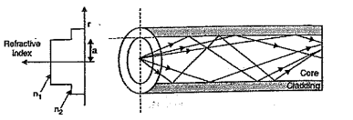

As the name indicates; the number of modes travel through the core layer.

The number of modes that can propagate through the fiber, depends on following factors:

1. Wavelength of incoming light
2. The diameter of core
3. The refractive indices of core and cladding layers.

Mathematically, the number of modes, that propagate through the fiber is given by,

Here λ = Wavelength of incoming light

d = Diameter of core layer

n1 =Refractive index of core

n2 = Refractive index of cladding.

**Advantages of multimode propagation**

1. Due to large core radius; the launching of optical power in the fiber is easy.
2. Connecting two fibers is easy compared to single mode fibers.
3. LED can be easily coupled to the fiber; as a light source.
4. Compared to single mode fiber; there is large refractive index difference between core and cladding layers. So, fabrication of such fibers is easy.

**Disadvantages**

1. The different mode follow the different paths. They are not reaching the output at same type. It produces intermodal dispersion.
2. The spreading of output pulse takes place.
3. For multimode step index fiber; bandwidth is limited. It is only 6 to 50 MHz/km.
4. Due to large amount of intermodal dispersion; multimode fibers are not suitable for long distance communication.

**Multimode Graded index fibers:**

1. Graded index fibers do not have a constant refractive index in the core but a decreasing core index n(r) with radial distance from a maximum value of n1 at the axis to a constant value n2 beyond the core radius a in the cladding.
2. This index variation may be represented as:

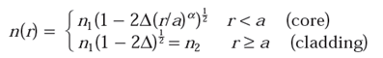

Where Δ is the relative refractive index difference and α is the profile parameter which gives the characteristic refractive index profile of the fiber core.

1. Above equation which is a convenient method of expressing the refractive index profile of the fiber core as a variation of α, allows representation of the step index profile when α=∞, a parabolic profile when α=2 and a triangular profile when α=1.
2. This range of refractive index profiles is illustrated in Figure 1.28.

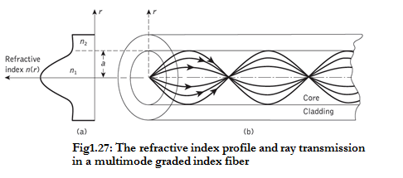

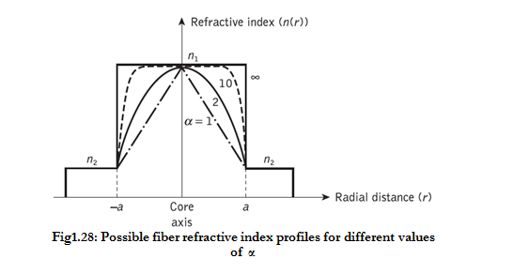

1. **Derive an expression for number of modes in SIF**

**Multimode step index fiber**



As the name indicates; the number of modes travel through the core layer.

The number of modes that can propagate through the fiber, depends on following factors:

1. Wavelength of incoming light
2. The diameter of core
3. The refractive indices of core and cladding layers.

Mathematically, the number of modes, that propagate through the fiber is given by,

Here λ = Wavelength of incoming light

d = Diameter of core layer

n1 =Refractive index of core

n2 = Refractive index of cladding.

**Propagation in Multimode Step Index Fibers:**

* Basically the 'V' number of multimode fiber is greater than 1.1505; so the fiber supports different modes.
* The refractive index profile and number of modes propagating through multimode step index fiber, is

shown in Fig.

* The core diameter is larger than single mode fibers and the core to cladding refractive index ratio is efficient.
* The number of guided modes depend on relative refractive index difference, core radius and wavelengths.
* There is a cut off value of normalized frequency (V) below which the guided modes do not exists.
* It does not mean that, the propagation will be stopped; but the propagation takes place in the form of leaky

modes.

* In case of multimode fibers; the different modes follow, the different paths in the core layer.
* Because of this, all the modes do not arrive at the output; at the same time. It produces dispersion.
* In case of multimode step index fiber, the cut off condition is given by,

$$n_{2}K < β<n_{1}K$$

Here, K = $\frac{2π}{λ}$

$n_{1}$ = Refractive index of core

$n_{2}$ = Refractive index of cladding

$β$ = Propagation constant.

* Cut off is the condition at which the normalized frequency (V) becomes equal to the normalized cut off frequency (V).
* At this condition the propagation of waves through optical waveguide stops.
* But in practical cases, the propagation of waves is not stopped. In this case the guided modes are converted

into leaky modes.

1. 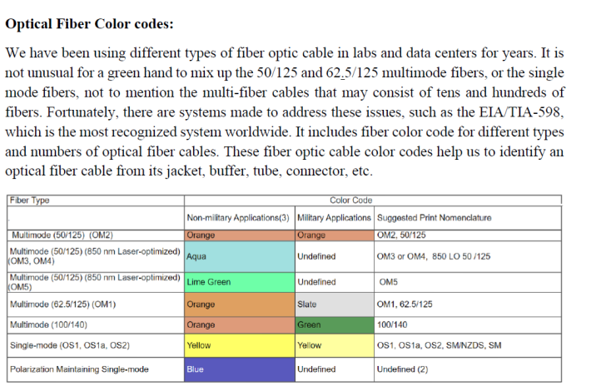**Neat sketch and the color codes of optical fiber**
2. **V-number, significance of v-number**

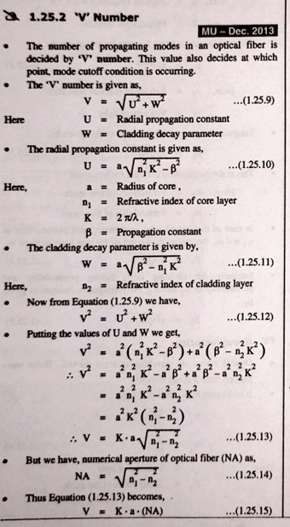

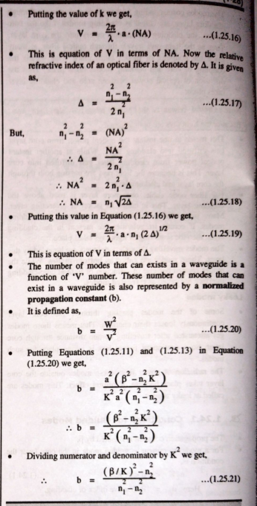

**Significance of v-number:**

* If number is less than 2.405, the fibre is considered as to be operating in single mode and if greater than 2.405, the fibre is operating in multimode.
* So, the V number lies in its ability to determine whether a fiber will operate in single mode or multimode, thereby influencing the performance and suitability of the fiber.

1. **Derive expression of cutoff wavelength for a single mode SIF.**

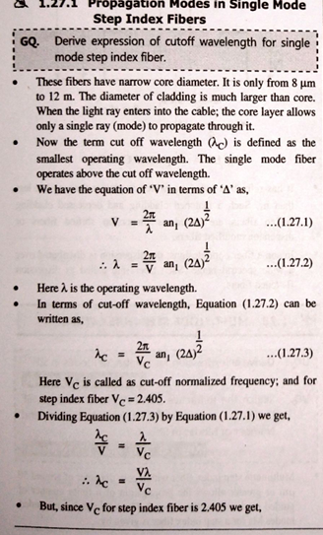

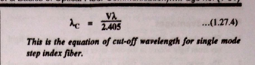

1. **Derive relation between number of modes and V number.**

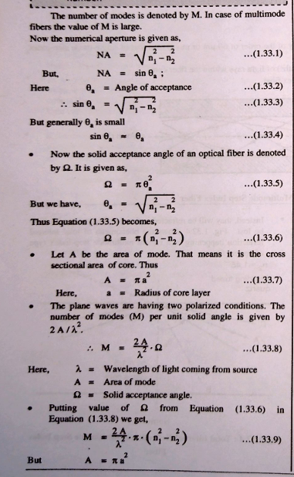

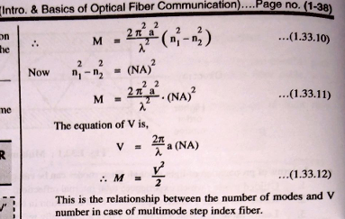

1. **Derive expression for propagation mode in Multimode graded index fiber.**

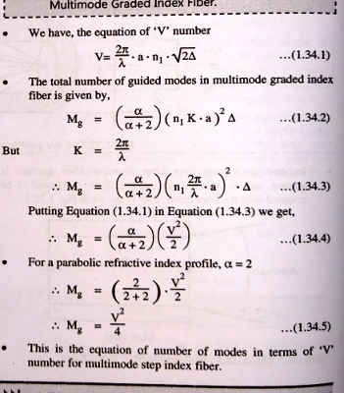

1. **Compare the different methods of fabrication**

|  |  |  |  |
| --- | --- | --- | --- |
| Sr. No. | Parameter | MCVD | PCVD |
| 1 | Oxidation Temperature | Oxidation takes place at high temperature | Oxidation takes place at low temperature |
| 2 | Oxidation Flame | A flame is used for oxidation | Non-isothermal plasma is used for oxidation |
| 3 | Operating Temperature | Higher operating temperature | Lower operating temperature |
| 4 | Stress | Mechanical stresses are developed | No mechanical stresses |
| 5 | Soot Formation | There is soot formation | No soot formation |
| 6 | Sintering | Sintering is required | Sintering is not required |

|  |  |  |  |
| --- | --- | --- | --- |
| Sr. No. | Parameter | OVPO Process | MCVD Process |
| 1 | Fabrication | The soot preform is deposited outside the rotating rod. | The chemical reactions take place inside the tube and soot is deposited inside the tube. |
| 2 | Reactant | The reactions of SiCl4, GeCl4, and O2 in a hot flame produce soot. | The major reactants used are SiCl4 and O2. |
| 3 | Holes | The preform has holes which get collapsed during drawing of fiber. | Preform does not contain hole. |
| 4 | Temperature & Process | Oxidation takes place around 1900°C. | Sintering takes place around 1500°C. |
| 5 | Flame for Heating Purpose | Methane oxygen flame is used for heating purpose. | Oxy-hydrogen flame is used for heating. |

|  |  |  |  |  |
| --- | --- | --- | --- | --- |
| **Method** | **Reaction Type** | **Dimensional Direction** | **Refractive Index Formation** | **Process** |
| OVPO | Flame Hydrolysis | Outside Layer Deposition | Profile | Batch |
| MCVD | Chemical Vapor Dimension | Inside Layer Deposition | Layer Approximation | Batch |
| PCVD | Chemical Vapor Dimension | Inside Layer Deposition | Layer Approximation | Batch |
| VAD | Flame Hydrolysis | Axial Layer Deposition | Simultaneous Formation | Continuous |

1. **Fabrication method:**

**OVPO**

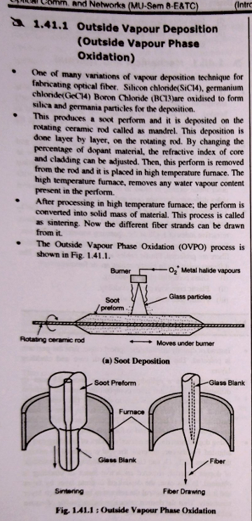

**VAD**

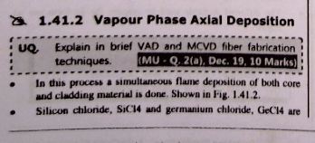

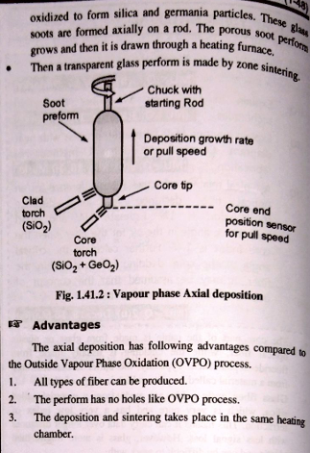

1. **Describe two methods of splicing individual fibers together. What are the advantages and disadvantages of each method?**

The splices are used to connect the two fiber optic cables permanently. The basic requirements of splices are :

* + - * 1. Splices should cause the minimum power loss.

(ii) They should be easy to install.

(iii) They should cause a low attenuation.

(iv) They should be strong and having light weight.

There are two techniques in splicing of optical fibers depending on the insertion loss, cost, and performance

characteristics. This splicing technique are :

* Fusion splicing
* Mechanical splicing.

The mechanical splicing is again divided as :

* Precision tube splice
* Loose tube splice
* V-groove splice
* Elastomeric splice
* Precision pin splice
* Spring groove splice.

The two optical fiber cables should be aligned properly while splicing and at the same time its geometrical factors and the mechanical strength should be considered.

**Fusion Splicing**

* Fusion Splicing is used to make permanent connection between the two optical fiber cables and gives a longer life with less attenuation.
* The two cores of fiber cables are joined or fused electrically or thermally. That means an electric device or an electrical arc is used to fuse the two fiber optic cables and produces a connection between them.
* This technique is very costly and works for a longer period. The Fig.1.54.1. shows of the fusion splicing of optical fiber technology.

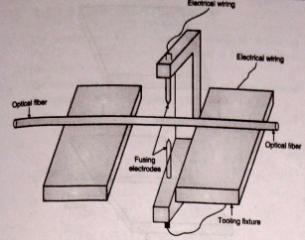

* The two fiber cables are aligned together by using a device called a fusion splicer. Those cables can be fused or joined together to form a connection with the help of an electric arc more precisely.
* The heat produced by the electric arc can give a transparent and continuous non-reflective connection between the two optical fiber cables with less attention, and insertion losses.
* The light loss will be low in this technique. So, it is most widely used and expensive than mechanical splicing of optical fiber cable.

**Advantages**

1. It provides lowest attenuation.
2. It provides high quality joint.
3. It has small size of splice.
4. It is very compact
5. It has the lowest insertion loss
6. It has the lowest back reflection (optical return loss ORL)
7. It has the highest mechanical strength
8. It is permanent
9. It can withstand extreme high temperature changes
10. It prevents dust and other contaminants from entering the optical path

**Disadvantages**

1. The heat is used for splicing, so makes the fiber ends weak.
2. After splicing, the tensile strength becomes low.
3. The cost of fusion splicing is very high mainly because of expensive fusion splicing device.
4. It requires a constant power supply and some special tools.
5. There are some situations where fusion splicing is not practical or we can say it is impossible, so as an alternative, we have to use mechanical splicing.
6. It is a time consuming process and can't be used for temporary connections.
7. Fusion splicers need periodic maintenance which involves regular cleaning, electrode alignment and occasional replacement.
8. It is mainly used with single mode fiber unlike mechanical splicing which works for single mode fiber, as well as, multi mode fiber

**Mechanical Splicing**

* It uses index matching fluid to hold and align the single or more fiber cables assembled in a place to join them together.
* The mechanical splicing acts as a junction to join the optical cables more precisely. When the optical fiber cables are joined together to pass the light from one to another, the loss of light will be low if we use the mechanical splicing technique. Insertion loss, splicing loss will be nearly 0.3dB.
* It produces high back reflection when compared to fusion splicing. It is very easy to repair and install for both multimode and single-mode optical fiber cables. In this method, the fiber ends are aligned and then they are locked in position using various positioning devices.

**Precision Tube Splice**

* In this case a precision tube is used to splice the two fiber optic cables. The schematic of this splice is as shown in Fig.
* Initially the ends of optical fiber to be joined are polished. A splicing compound is added in the precision tube. This compound is having the same refractive index as the fibers to be joined.
* Then the two optical fibers are inserted into the precision tube from two ends. The two ends of optical fibers are joined and the outer jacket is crimped.

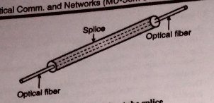

**Precision Pin Splice**

* The arrangement of precision pin splice is shown in Fig. The heat shrink tube is used to held three steel pins together.
* The fibers tube joined are inserted in the openings between three pins. Using index matching epoxy, splicing is done.

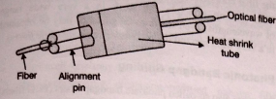

**Loose Tube Splice**

* Here a rectangular tube is used for splicing. The tube has a square hole as shown in Fig.
* An adhesive material is added in the tube to join the ends of optical fiber. Then the optical fibers are inserted from two ends of the tube.
* Because of adhesive material the two ends of optical fiber are joined. The adhesive material is having the same refractive index as that of the fiber optic cables.

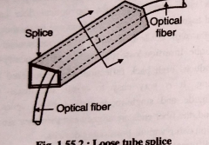

**Spring Groove Splice**

* Two cylindrical pins are used as alignment guide for two prepared fiber ends.
* Using the spring, the fiber is pressed in the groove and alignment is maintained.
* Epoxy resin is used for splicing. This type of splice is shown in Fig.

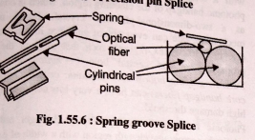

**Advantages and Disadvantages of Mechanical Splicing**

**Advantages**

Mechanical splices require no power supplies.

Many mechanical fiber splice designs require no extra tools beyond a fiber stripper and fiber cleaver.

They can be used in situations where fusion splicing is not practical or impossible.

Mechanical splices can be made within a couple of minutes, this makes it ideal for temporary connections.

**Disadvantages**

Higher insertion loss. The typical insertion loss for a mechanical splice is about 0.2dB which is significantly higher than the 0.02dB loss for a typical fusion splice.

Mechanical splices are typically for multimode fibers. The tough alignment tolerance for single mode fibers makes it hard for mechanical splices to meet.

Mechanical splice is more expensive than fusion splices. But if you take into account the expensive fusion splicing machines that fusion splices need, the average cost is actually much lower for mechanical splice if you just do a few splices.

|  |  |  |  |
| --- | --- | --- | --- |
| **Sr. No.** | **Parameters** | **Fusion Splicing** | **Mechanical Splicing** |
| 1 | Process | Two ends of optical cables are fused using heat, connecting the cables. | Fiber ends are aligned and locked in position without heat. |
| 2 | Size | Small | Large |
| 3 | Attenuation | Lowest attenuation (about 0.5 dB) | Higher attenuation |
| 4 | Usage of Heat | Heat weakens fiber ends | No heat applied |
| 5 | Tensile Strength | Becomes low after splicing | Unaffected by splicing |

**Module 2**

1. **Discuss Bending Loss? How it can be minimized**

Ans: Bending an optical fiber too sharply can increase fiber loss and prevent total internal reflection.

* If there is abrupt change in the radius of curvature of fiber; then the radiation loss takes place from the fiber.
* If there is sharp bend of the fiber then there is a probability of mechanical failure of optical cable.
* Usually the higher order modes are not tightly bound to the core layer; so due to the sharp bends, the radiation losses of such modes take first.
* There are two types of fiber bending losses:

1. Macroscopic bending losses
2. Microbending losses or mode coupling losses.

**Macroscopic bends:**

* There is a radiation loss, when the radius of curvature of bend is greater than the diameter of fiber. Such losses are also called as large radius losses.
* As the radius of curvature of bend decreases, such losses increase exponentially.
* The part of the mode which is on the outside of the bend is required to travel faster than that on the inside so that a wavefront perpendicular to the direction of propagation is maintained. Hence, part of the mode in the cladding needs to travel faster than the velocity of light in that medium. As this is not possible, the energy associated with this part of the mode is lost through radiation and thus results in attenuation.

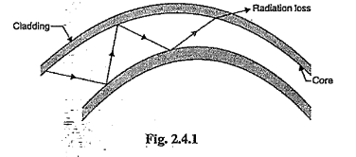

**Microscopic bend:**

* The microbends are caused either by non-uniformities in the manufacturing of the fiber or by non-uniform lateral pressures created during the cabling of the fiber. Due to this microbends, energy is coupled from the guided modes to the leaky or nonguided modes in the fiber.
* To minimize the microbending losses is by extruding a compressible jacket over the fiber when external forces are applied to this configuration, the jacket will be deformed but the fiber will tend to stay relatively straight.

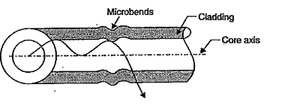

.

**To minimize the losses following precautions are taken**

* While manufacturing the cable; a precise control of core diameter is maintained.
* A compressible jacket is fitted over the fiber, so that when the external pressure is applied then the deformation of jacket takes place and there will not be creation of microbends in the core layer of fiber.

1. **What are the different factors responsible for attenuation in optical fiber.**

* Basically, attenuation represents the reduction in amplitude of signal.
* In case of fiber optic cable, attenuation is also called as the transmission loss and it represents the reduction in intensity of light rays propagating through it.
* This attenuation is measured with respect to the distance travelled by light rays in optical cable.
* Thus, attenuation is basically related to the losses in the signal and in case of fiber optic cable, attenuation is caused due to scattering and absorption of light rays. Attenuation is usually expressed in decibel (dB).
* Let input power launched into the fiber is Pi, and the fiber output is Po, then attenuation in dB is,

Attenuation (α) = $10\log_{10}{(\frac{P_{i}}{P_{o}})}$

In case of optical cable, attenuation is expressed in terms of decibels per unit length that means dB/km.

∴ $αL = 10\log_{10}{(\frac{P_{i}}{P_{o}})}$

Here α = Attenuation of signal per unit length

L = Length of fiber optic cable

The signal attenuation produces losses in the system. The different factors responsible for attenuation are as follows:

1. Material absorption losses

(a) Intrinsic (b) Extrinsic

1. Linear scattering losses
2. Losses due to non-linear scattering
3. Losses due to stimulated Raman scattering
4. Fiber bending losses
5. Dispersion

(a) Material dispersion

(b) Waveguide dispersion

(c) Intermodal dispersion

(d) Polarized mode dispersion.

**different factors responsible for attenuation**

1. **Bending loss**

1. Once fiber is laid as cables for communication purpose bending losses occur.

2. Optical fibers suffer radiation losses at bends or curves on their paths.

* 1. **Macrobending loss**
* Fiber is subjected to gentle bend over a large arc, this bend causes failure of total internal reflection condition of a optical signal at the core-cladding interface which leads to leakage of optical signal from the fiber.
* This causes macrobending loss.
  1. **Microbending losses**
* Microbends are caused either by non-uniformities in the manufacturing of the fiber or by non-uniform lateral pressures created during the cabling or packaging losses.
* When a light beam strikes these imperfections in the fiber, the condition of total internal reflection is not attained and the beam leaks out of the core causing microbending losses.

1. **Absorption loss**

Absorption is caused by three different mechanism:

* Intrinsic absorption by basic constituent atoms of fiber material
* Extrinsic absorption by impurity atoms in silica material
* Absorption by atomic defects in the composition of glass

**3. Scattering loss**

Scattering losses in glass arise from microscopic variations in the material density, from compositional fluctuations and from structural inhomogeneties or defects occurring during fiber manufacture,

1. **Explain Material attenuation in optical communication**

During fabrication process, some of the transmitted light is dissipated as heat. It is called as material absorption loss.

The major factors responsible for material absorption loss are as follows :

* 1. Intrinsic absorption due to basic atoms of fiber material.
  2. Extrinsic absorption due to impurity atoms.
  3. Absorption due to atomic defects in the glass material.

**Intrinsic Absorption**

* Optical fibers are normally made of silica-based glass material. As light energy passes through the fiber, it may be partially absorbed by this material itself. This is called intrinsic absorption.
* It is mainly caused by the interaction with major components of the fiber material.
* Two factors cause intrinsic losses - Material resonances in UV and IR regions, and Rayleigh scattering. Silica displays heavy absorption in the UV and IR regions and is wavelength-dependent.

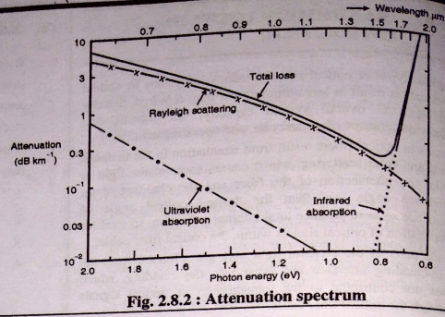

* In near infrared region, the intrinsic absorption takes place due to the basic fiber material

properties.

* Usually, pure silica glass shows low intrinsic absorption.
* At the short wavelengths (ultraviolet region); intrinsic absorption is more dominant.
* In IR region, the absorption peaks are present around the operating wavelength range 700 nm to 1200 nm.
* Basically an interaction between vibrating SiO band and electromagnetic field of optical region takes place and it produces intrinsic absorption.

**extrinsic absorption.**

* There may be some impurities within the fiber material which may absorb some part of light energy. This is called extrinsic absorption.
* Optical fibers are manufactured using melting techniques.
* During this process, the metallic ions like Cu2+, Fe2+, Ni2+ etc. gets deposited.
* These are metal element impurities, which causes absorption of incoming photons and it is called as extrinsic absorption.
* Similarly the OH ions or hydroxyl dissolved in the glass also produces extrinsic absorption.
* Basically OH ions form SiOH bond and it has fundamental absorption at 2700 nm.
* But the harmonics of these fundamental frequencies at 1380 nm, 1250 nm and 950 nm also produces extrinsic absorption.
* This type of absorption can be reduced by reducing amount of impurities and by reducing the level of OH.

1. **What are the different factors responsible for dispersion and what is dispersion in optical fiber.**

**Dispersion**

* Dispersion is the broadening of actual time-width of the pulse due to material properties and imperfections.
* As pulse travels down the fiber, dispersion causes pulse spreading. This limits the distance travelled by the pulse and the bit rate of data on optical fiber.
* In a fiber three distinct types of distortion are observed:

**Intramodal dispersion**

* Pulse broadening within a single mode is called as intramodal dispersion or chromatic dispersion.
* The two main causes of intramodal dispersion are as follows:
  + **Material dispersion**
  + It is the pulse spreading due to the dispersive properties of material.
  + It arises from variation of refractive index of the core material as a function of wavelength.
  + **Waveguide dispersion**
  + It occurs because a single mode fiber confines only about 80% of the optical power to the core.
  + Dispersion thus arises since the 20% light propagating in the cladding travels faster than light confined to the core.

**Intermodal dispersion**

* Dispersion caused by multipath propagation of light energy is referred to as intermodal dispersion.
* In digital transmission, we use light pulse to transmit bit 1 and no pulse for bit 0. When the light pulse enters fiber it is breakdown into small pulses carried by individual modes.
* At the output individual pulses are recombined and since they are overlapped receiver sees a long pulse causing pulse broadening.

**Polarization mode dispersion**

* Birefringence is the optical property of a material having refractive index that depends on the polarization and propagation direction of light.
* Varying birefringence along the length of the fiber causes each polarization mode to travel at slightly different velocity and polarization orientation changes with distance.
* The resulting difference in the propagation time between the orthogonally polarized modes causes pulse spreading and this leads to polarization mode dispersion.

1. **Differentiate intrinsic and extrinsic absorption loss.(2m)**

|  |  |  |
| --- | --- | --- |
| **Aspect** | **Intrinsic Absorption** | **Extrinsic Absorption** |
| Definition | Absorption due to fiber material properties. | Absorption due to impurities and defects in the fiber. |
| Cause | Interaction between vibrating SiO band and electromagnetic field. | Presence of metallic ions (e.g., Cu²⁺, Fe²⁺, Ni²⁺) and OH ions in the glass. |
| Material | Pure silica glass | Glass with impurities (e.g., metallic ions, OH ions) |
| Wavelength Range | Dominant in near infrared region (700 nm to 1200 nm). | Can occur across various wavelengths, including 2700 nm (fundamental absorption of OH ions) and its harmonics at 1380 nm, 1250 nm, and 950 nm. |
| Reduction Method | Control of electronic band gaps; Purity of constituent materials | Reduce impurities and OH ion levels in the glass. |

1. **Compare Intermodal and Intramodal dispersion**

|  |  |  |
| --- | --- | --- |
| **Sr. No.** | **Intermodal Dispersion** | **Intramodal Dispersion** |
| 1 | It takes place in all types of fibers. | It takes place only in multimode fibers. |
| 2 | It is also called as material dispersion. | It is also called as modal dispersion. |
| 3 | Less pulse broadening. | More pulse broadening. |
| 4 | This type of dispersion occurs because different colors of light travel with different speed. | This type of dispersion occurs due to variation in group delay for individual mode at a single frequency. |

1. **Discuss different types of Dispersion in optical fiber. Explain in brief intermodal and intramodal dispersion in fiber.**

**Definition :** Dispersion means spreading out of an optical pulse of light energy in time as it propagates down a fiber. It is also called as pulse spreading. Dispersion occurs because of the difference in the propagation time taken by the light rays that traverse differ propagation paths within the fiber. If the pulse spreading is sufficiently severe, one pulse may interfere with another Shows dispersion.

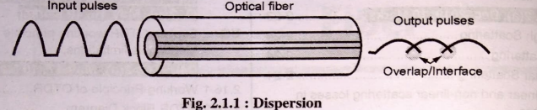

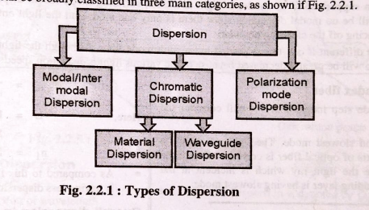

**Chromatic or Intramodal Dispersion**

* It is results from the finite spectral linewidth of the optical source.
* Propagation delay differences between the different spectral components of the transmitted light signal causes broadening of each transmitted mode and hence collectively known as intramodal dispersion**.**
* It may occur in all types of optical fibers (single-mode , multimode, step-index and graded-index). It is caused by the dispersive properties of the fiber material (material dispersion) and also guidance effects within the fiber structure (waveguide dispersion).

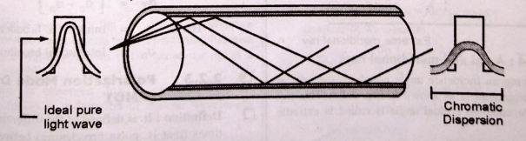

* This intramodal dispersion is again divided into two types:

1. **Material dispersion**

* The material dispersion depends on the refractive index of material used to manufacture the fiber optic cable.
* The group velocity is the function of wavelength of light and the group velocity is also the function of

refractive index of the material.

* Now depending on the light source, each spectral component of input source will be having different

wavelength.

* Thus each component is travelling with different speed through optical fiber.
* This gives the spreading of the output pulse.
* Thus is called as the material dispersion. It is denoted by Dm
* It is given as,

$$D_{m}= \frac{σ_{m}}{L σ_{λ}}$$

Here, $σ_{m}$ = Width of pulse spread because of material dispersion

L = Length of fiber optic cable

$σ_{λ}$ = spectral width of source

In terms of wavelength,

$$D_{m}= \frac{λ S_{0}}{4} \left[1- {\left(\frac{λ_{0}}{λ }\right)}^{4}\right]$$

Here, $S_{0}$ = Zero dispersion slope

X0 = Zero dispersion wavelength

It is also given by,

$$D_{m}= M_{D}=\frac{λ }{c} \left|\frac{d^{2}n}{dλ^{2}}\right|$$

Here, $λ$ = Operating wavelength

c = Speed of light

n = Refractive index of core

2. **Waveguide dispersion**

* Whenever the optical signals are passing through the fiber optic cable, then the optical cable is acting as a wave guide.
* Now there is a variation in the wavelength of each spectral component emitted from the source.
* As well as the angle made by each light ray with respect to the axis of optical cable will be different.
* Because this angle is the function of wavelength of light.
* Since there is variation in the angles, all the light rays are not reaching to the output at the same time.
* This gives dispersion at the output. This is called as waveguide dispersion.
* In case of multimode fibers almost all the light rays are travelling away from cut off axis.
* So in this case the waveguide dispersion is negligible.
* In case of single mode fiber, the waveguide dispersion given as,

$$D_{w}= \frac{σ_{w}}{L σ_{λ}}$$

$σ_{w}$ = Width of pulse spread because of waveguide dispersion

L = Length of optic fiber

$σ_{λ}$ = spectral width of source

**Intermodal Dispersion or Mode Dispersion**

* Modal dispersion is a distortion mechanism occurring in multimode fibers and other waveguides, in which the signal is spread in time because of different propagation velocity for all modes.
* Since light rays entering the fiber at different angles of incidence will go through different paths/modes. Some of these light ravs will travel straight through the center of the fiber (axial mode) while others will repeatedly bounce off the cladding/core boundary to zigzag their way along the waveguide, as illustrated below with a step-index multimode fiber.
* Whenever there is a bounce off, modal dispersion (or intermodal dispersion) happens. The longer the path is, the higher the model dispersion will be.
* For example, the high-order modes (light entering at sharp angles) have more model dispersion than low-order modes (light entering at smaller angle).

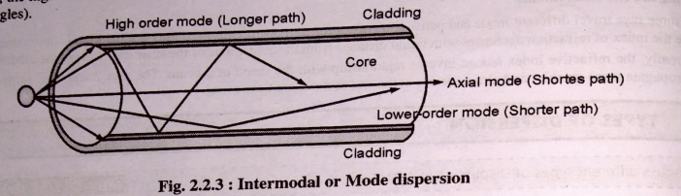

* Multimode fiber can support up to 17 modes of light at a time, suffering much modal dispersion. Whereas, if the fiber is a single mode fiber, there will be no modal dispersion since there is only one mode and the light enters along the fiber axis (enters in axial mode) without bouncing off the cladding boundary.
* However, things are different if one uses a graded-index multimode fiber. Although the light rays travel in different modes as well, the modal dispersion will be greatly decreased because of the various light propagation speeds.

**Polarization Mode Dispersion**

* The orientation of electric field of light signal is called as polarization.
* The polarization varies significantly throughout the length of fiber optic cable.
* Two orthogonal polarization modes are shown in Fig.

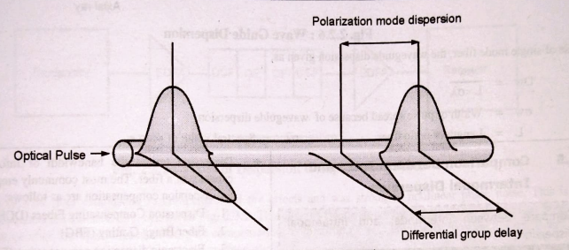

* The two modes travel with slightly different propogation velocities and because of this, the dispersion takes place.
* The polarization orientation rotates or shifts with distance.
* The difference in propogation time ($Δτ$) between two orthogonal polarization modes, cause the spreading of pulse. It is called as Polarization Mode Dispersion (PMD).
* This polarization occurs because of varying birefringence along the length of fiber.
* If $β_{x}$ and $β_{y}$, are different propogation constants and A. is the optical wavelength then the modal birefringence (BF) of fiber is given by,

$$B_{F}= \frac{β_{x}- β_{y }}{\frac{2π}{λ}}$$

1. **Explain linear and non-linear scattering losses in optical fiber. [10m]**

**Scattering:**

* Due to the non-uniformities in fiber optic cable; a straight line path of light rays gets deviated. It is referred as scattering. Scattering loss occurs due to transfer of the optical power available within one guided propagation mode into a different mode of propagation.
* The scattering may happen when a light beam propagating within the fiber strikes at an imperfection in a core material and then changes its direction. This scattering effect prevents attainment of desired total internal reflection at the intersection of the fiber core and the cladding. This may result in a power loss.
* Even very minute variation in the specified value of the core refractive index can be considered as an optical obstacle by a propagating light beam. In case of optical cable; some of the optical power from one propagating mode gets transferred to another mode.
* This transfer of power takes place through the leaky or radiation mode. This leaky mode does not continue to propagate within the fiber core, but it is radiated out from the fiber. It produces the scattering loss.
* These losses are mainly caused by interaction of light with density fluctuations within a fiber. This density fluctuations occur when the fiber is produced.
* Basically the glass is composed of randomly connected network of molecules, which is made up of several oxides and it increases the compositional fluctuations.
* In case of multimode fibers, there is a higher dopent concentration and greater compositional fluctuations. Thus scattering losses are more.

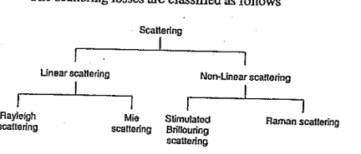

**Linear Scattering**

In case of linear scattering; optical power gets transferred from one mode to another mode. But there is no change of frequency on the scattering.

(i) Rayleigh Scattering

(ii) Mie Scattering

1. **Rayleigh Scattering**

* The light from the sun is scattered in atmosphere to give the sky color blue.
* Rayleigh scattering in the glass is having same phenomenon and this scattering takes place in all directions.
* The Rayleigh scattering produces attenuation in the light rays and this attenuation is proportional to $\frac{1}{λ^{4}}$ where $λ$ is optical wavelength.
* Thus if we transmit the data through the fiber optic cable at lower wavelength; the scattering is minimized.

The Rayleigh scattering coefficient is denoted by $γ_{R}$ and it is given by,

$$γ_{R}= \frac{8π^{3}}{3λ^{4}}.n^{8}. p^{2} .β_{c} .K. T_{F}$$

$λ$ = Optical wavelength

n = Refractive index of the medium

P = Average photoelastic coefficient

$β_{c}$ = Isothermal compressibility temperature

K = Boltzmann's constant

$T_{F}$ = Fictive temperature

The temperature at which the glass can reach a state thermal equilibrium is called as fictive temperature.

The transmission loss factor is called as transmissivity of the fiber. It is denoted by $Ψ$ and it is related to Rayleigh coefficient as,

$$Ψ= e^{-γ_{R}L}$$

where L = Length of optical cable

1. **Mie Scattering**

* The scattering caused by homogenetics which are comparable in size with guided wavelength; are called as Mie scattering.
* This is a linear scattering, which is always in forward direction.
* The different factors, responsible for Mie scattering are as follows :

1. The cylindrical structure of optical cable is not perfect.
2. Imperfections or irregularities in the core cladding interface.
3. Core-cladding refractive index differences, along the fiber are not uniform.
4. There are fluctuations in the core diameter.
5. There can be presence of bubble or strain in the fiber material.

* Thus, Mie scattering can cause significant attenuation in optical signal, depending on the fiber material, manufacturing process and design.
* Mie scattering can be reduced by performing following steps :

(i) Removing imperfections during glass manufacturing process.

(ii) Controlling the coating of fiber.

(iii) Increasing the relative refractive index difference between core and cladding.

**Non-Linear Scattering**

* When the optical power is transferred from one mode to another mode or same mode, but at different

frequencies; then it is called as non linear scattering.

* This scattering takes place either in forward or backward direction.
* The non-linear scattering mechanism actually produces optical gain but there is a shift in frequency.
* When the light is transmitting through the fiber optic cable at a specific wavelength then due to nonlinear scattering there is change in frequency; so it produces attenuation.
* There are two types of nonlinear scattering as follows

Stimulated Brilliouin Scattering (SBS)

Stimulated Raman Scattering (SRS)

1. **Stimulated Brilliouin Scattering (SBS)**

* When the laser light beam is travelling in optical cable; there are variations in an electric field of this beam.
* These variations in electric field produces acostic vibrations in the optical cable.
* That means incident photon produces a phonon (vibrational quanta) of acostic frequency as well as it produces a scattered photon.
* This type of scattering is called as stimulated Brillouin scattering and this scattering is usually in opposite direction to that of incoming beam.
* The scattered light looks like upper and lower sidebands, which are separated from the incident light by the modulation frequency.
* During this scattering, a frequency shift is produced which varies with the scattering angle. This frequency shift is maximum in the backward direction.

1. **Stimulated Raman Scattering (SRS**)

* Raman scattering basically represents inelastic scattering of photons.
* When a laser light is travelling through optical cable; the spontaneous scattering takes place.
* In this process; some of the photons are transferred to the near frequencies.
* When the scattered photons lose their energy then it is called as stokes shift and when the scattered photons gain the energy then it is called as antistoke shift.
* But if the photons of other frequencies are already present then the scattering of such photons takes place and in this case the two photons are generated. It is called as stimulated raman scattering.
* This scattering is similar to Stimulated Brilliouin Scattering (SBS) but in SRS instead of acaustic photon; a high frequency optical phonon is created.
* The SRS can occur in both forward and backward directions.
* In SRS, optical threshold power is higher than SBS and it is given by,

PR = 5.9 x10-2 d2 λ α

* + d = Diameter of core layer (in um)
  + λ = Operating wavelength
  + α = Attenuation in dB/km

1. **Compare Linear and Nonlinear Scattering [5m]**

|  |  |  |
| --- | --- | --- |
| Characteristic | Linear Scattering | Non-Linear Scattering |
| Types | Rayleigh Scattering, Mie Scattering | Stimulated Brillouin Scattering (SBS), Stimulated Raman Scattering (SRS) |
| Direction | Can occur in all directions (Rayleigh); Generally forward (Mie) | Can occur in both forward and backward directions (SBS, SRS) |
| Frequency Change | No change in frequency | Change in frequency |
| Mechanism | Transfer of optical power between modes without frequency change | Transfer of optical power between modes with frequency change |
| Frequency Shift | None | Present |
| Frequency Shift Direction | No frequency shift (Rayleigh); Forward direction (Mie) | Can occur in both forward and backward directions (SBS, SRS) |
| Attenuation Effect | Attenuation proportional to $\frac{1}{λ^{4}}$ (Rayleigh);  Depends on fiber material, imperfections, etc. (Mie) | Frequency shift introduces attenuation |
| Reduction Techniques | Controlling optical wavelength, minimizing imperfections, uniformity in core-cladding refractive index (Rayleigh); Improving manufacturing process, controlling fiber coating, increasing relative refractive index difference (Mie) | Proper fiber design, threshold power calculations, controlling operating parameters (SBS, SRS) |

1. **Explain OTDR working principle in detail.**

* It is an optoelectric instrument used to measure the characteristic of optical fiber.
* It gives an idea of abnormalities or faults in optical cable.
* It is also used to measure the signal attenuation passing through optical cable as well as to measure the length of cable under test.
* In fiber-optic communication, a signal is transmitted inside an optical fiber. A measurement technique which is far more sophisticated and which finds wide application in both the laboratory and the field is .the use of optical time domain reflectometry (OTDR).
* This technique is often called the backscatter measurement method. It provides measurement of the attenuation on an optical link down its entire length giving information on the length dependence of the link loss. When the attenuation on the link varies with length, the averaged loss information is inadequate.

**Principle:**

* If these are discontinuities in the optical cable; then scattering of light takes place.
* Especially, whenever there is change in refractive index then light passing through optical cable gets scattered.
* Some of the scattered light moves towards the source, that means in backward direction. It is called as backscattered light.
* OTDR uses this backscattered light to make its measurements.
* A pulsating laser, generates optical pulses and using optical circular or directional couplers; these pulses are passing to optical cable.
* In the optical cable; due to various reasons, the scattering of light takes place.
* Again using optical circulator, this backscattered light is passed to the optical defector.
* Using signal processing block; the signal is converted into the proper form for display.

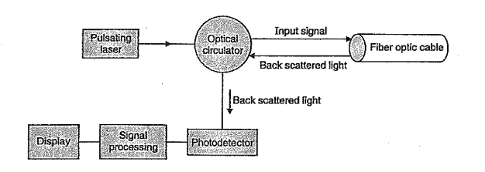

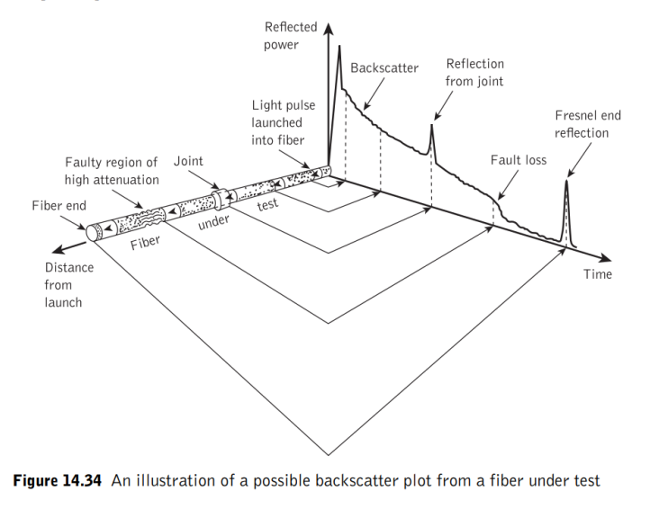

**Advantages**

* A number of optical time domain reflectometers are commercially available for operation over the entire wavelength range.
* These instruments are capable of carrying out tests over single or dual wavelengths for multimode and for single-mode optical fiber links.
* Although the OTDR functionality is provided, these instruments are also often capable of performing a number of other optical system and network tests (e.g. optical loss, dispersion measurement etc.).
* Such instruments are usually referred as universal or optical network test systems rather than simply optical time domain reflectometers.

**Disadvantages**

* The main disadvantage of OTDR is the occurrence of a dead zone during measuring the defects.
* The dead zone of an OTDR is a crucial parameter. It is the distance in the fiber cable at which the defects cannot be measured properly. a dead zone occurs, In case a very major portion of the transmitted signal is reflected then the received power at the photodetector is highly greater than the backscattered power level.

**Applications:**

* An Optical Time Domain Reflectometer (OTDR) is an important instrument used by organizations to certify the performance of new fiber optics links and detect problems with existing fiber links.
* OTDRs are also used for maintaining fiber plant performance. An OTDR allows to see more detail impacted by the cabling installation. An OTDR maps the cabling and can illustrate termination quality, location of faults.
* An OTDR provides advanced diagnostics to isolate a point of failure that may hinder network performance.
* An OTDR allows discovery of issues along the length of a channel that may affect long term reliability.
* OTDRs characterize features such as attenuation uniformity and attenuation rate, segment length, location and insertion loss of connectors and splices, and other events such as sharp bends that may have been incurred during cable installation.

1. **Draw and explain block diagram of cutback method of attenuation measurement**

* Fiber attenuation measurement techniques have been developed in order to determine the total fiber attenuation of the relative contributions to this total from both absorption losses and scattering losses.
* The overall fiber attenuation is of greatest interest to the system designer, but the relative magnitude of the different loss mechanisms is important in the development and fabrication of low-loss fibers.
* Measurement techniques to obtain the total fiber attenuation give either the spectral loss characteristic or the loss at a single wavelength (spot measurement).
* A commonly used technique for determining the total fiber attenuation per unit length is the cut-back or differential method. Fig shows a schematic diagram of the typical experimental setup for measurement of the spectral loss to obtain the overall attenuation spectrum for the fiber.

It consists of a 'white' light source, usually a tungsten halogen or xenon are lamp. The focused light is mechanically chopped at a low frequency of a few hundred hertz. This enables the lock-in amplifier at the receiver to perform phase-sensitive detection.

* The chopped light is then fed through a monochromator which utilizes a prism or diffraction grating arrangement to select the required wavelength at which the attenuation is to be measured. Hence the light is filtered before being focused onto the fiber by means of a microscope objective lens. A beam splitter may be incorporated before the fiber to provide light for viewing optics and a reference signal used to compensate for output power fluctuations.

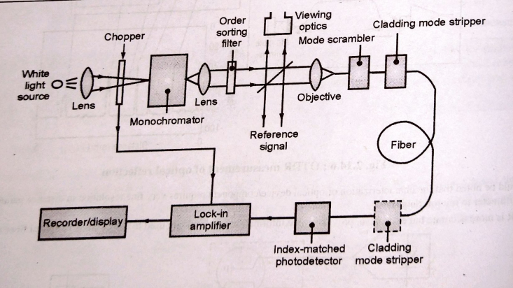

* When the measurement is performed on multimode fibers it is very dependent on the optical launch conditions. Therefore unless the launch optics are arranged to give the steady-state mode distribution at the fiber input, or a dummy fiber is used then a mode scrambling device is attached to the fiber within the first meter.
* The fiber is also usually put through a cladding mode stripper, which may consist of an S-shaped groove cut in the Teflon and filled with glycerin. This device removes light launched into the fiber cladding through radiation into the index-matched (or slightly higher refractive index) glycerin. A mode stripper can also be included at the fiber output end to remove any optical power which is scattered from the core into the cladding down the fiber length. This tends to be pronounced when the fiber cladding consists of a low-refractive-index silicone resin.
* The optical power at the receiving end of the fiber is detected using a p-i-n or avalanche photodiode. In order to obtain reproducible results the photo detector surface is usually index matched to the fiber output end face using epoxy resin or an index-matching gell. Finally, the electrical output from the photo detector is fed to a lock-in amplifier, the output of which is recorded.
* The cut-back method* involves taking a set of optical output power measurements over the required spectrum using a long length of fiber (usually at least a kilometer). This fiber is generally uncabled having only a primary protective coating. Increased losses due to cabling do not tend to change the-shape of the attenuation spectrum as they are entirely radiative, and for multimode fibers are almost wavelength independent.
* The fiber is then cut back to a point 2 m from the input end and, maintaining the same launch conditions, another set of power output measurements is taken.

$$α_{dB}= \frac{10}{L_{1}- L_{2} }\log_{10}{\frac{P_{01}}{P_{02}}}$$

Where L1 and L2 are the original and cut-back fiber lengths respectively, and P01 and P02 are the corresponding output optical powers at a specific wavelength from the original and cut-back fiber lengths.

Hence when L1 and L2 are measured in kilometers, αdB has units of dB km-1.

where V1 and V2 correspond to output voltage readings from the original fiber length and the cut-back fiber length respectively.

1. **Derive the expression for pulse spreading in intermodal dispersion.**

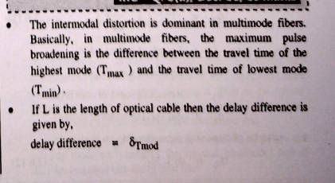

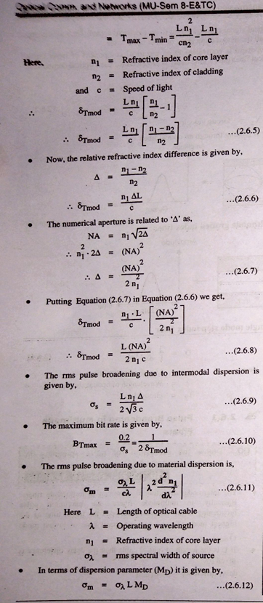

**Sums**

1. An optical fiber is made up of glass with a refractive index of 1.55 and its cladding with a refractive index of 1.51. Launching takes place from air. What numerical aperture does the fiber have? What is the acceptance angle? And what is the value of delta?
2. Calculate the number of modes at 1.3 μm wavelength in GIF having index profile α =2, core radius 25 μm, core refractive index 1.48 and cladding refractive index 1.46.
3. An optical signal at a specific wavelength has lost 55% of its power after traversing 3.5Km of fiber. What is the attenuation in dB/Km of this fiber.

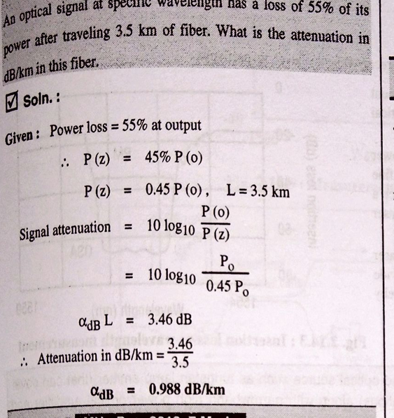

1. A 45o -45o -90o Prism is immersed in alcohol (n1=1.45), what is the minimum refractive index of the prism must have if a ray incident normally on one of the short faces is to be totally reflected at the long phase of the prism.
2. A step index multimode fiber with a numerical aperture of 0.20 supports approximately 1000 modes at an 850 nm wavelength. What is the diameter of its core?
3. When mean optical power launched into an 8 km length of fiber is 120 μW, the mean optical power at the fiber output is 3 μW. Determine (a) Overall signal attenuation in dB. (b)The overall signal attenuation for a 10 km optical link using the same fiber with splices at 1km intervals, each giving an attenuation of 1 dB.
4. If a multimode step Index fiber having the core refractive index of 1.5, cladding refractive index of 1.38, core radius of 25 um operates at a wavelength of 1300 nm. Calculate:
5. Numerical Aperture
6. Normalized frequency
7. Solid acceptance angle
8. Total no. of modes entering the fiber. [10m]
9. A silica optical fiber has core refractive index of 1.4 and cladding index of refraction is 1.35. Determine
10. The critical angle
11. Numerical
12. The acceptance angle [10m]
13. A silica optical fiber with core diameter large enough to be considered by Ray theory has a core refractive index of 1.5 and cladding refractive index of 1.47. Determine:
14. The critical angle.
15. The NA.
16. The acceptance angle[10]
17. A typical relative refractive index difference for an optical fiber designed for long distance transmission is 1 %. Estimate NA and solid acceptance angle in the air for the fiber when the core index is 1.46. Further calculate the critical angle at the core cladding interface within the fiber. It may be assumed that the concept of geometric optics hold for the fiber. [10m]